Data Modelling Report
Module: 4003SEQR
Student ID: 103589 – LJMU: 1143006
Introduction:
This report presents the development of a spreadsheet and database system for managing student attendance and a university library system. The report includes the implementation of formulas, data modelling techniques, and a database design using Microsoft Access.

Part 1:
- Formulas such as AVERAGE were used to calculate the overall performance of students based on their assessment scores. This allows automatic calculation and improves efficiency.
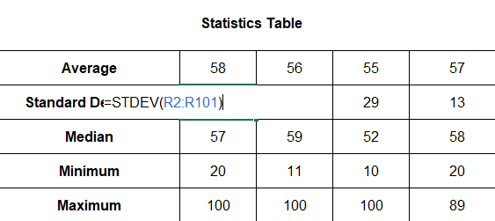
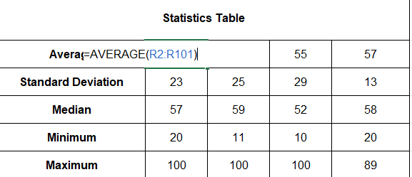
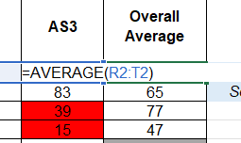
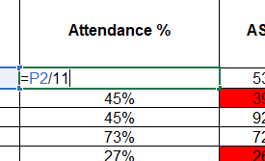

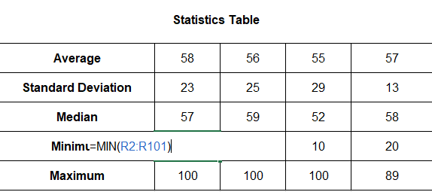
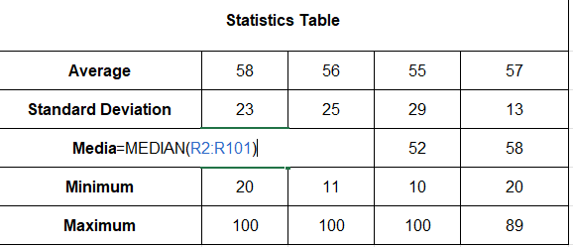
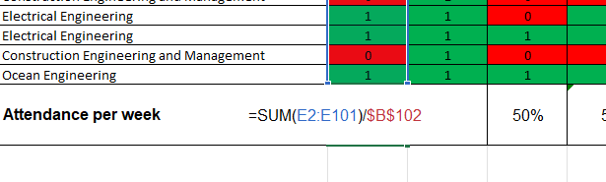
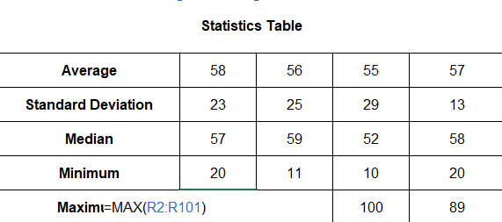

- Conditional formatting was applied to highlight low attendance and green for good attendance record. Same thing for Failed assignments red and overall less than 40 grey.
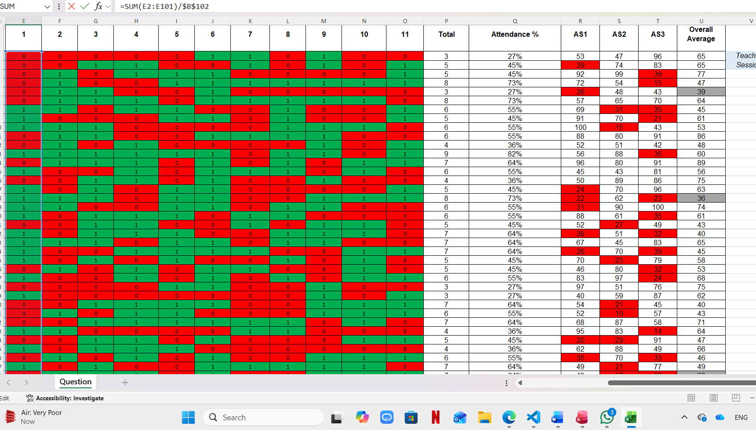

- A scatter plot was used to analyze the relationship between attendance and overall performance. A column chart was used to show attendance per week.
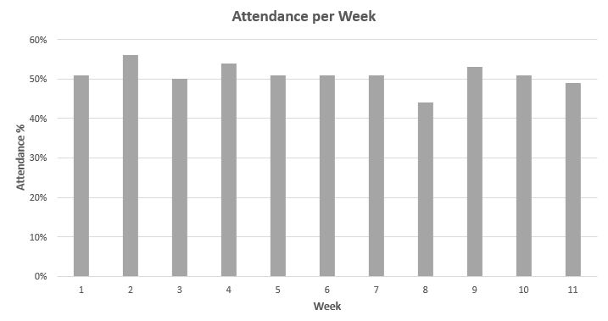
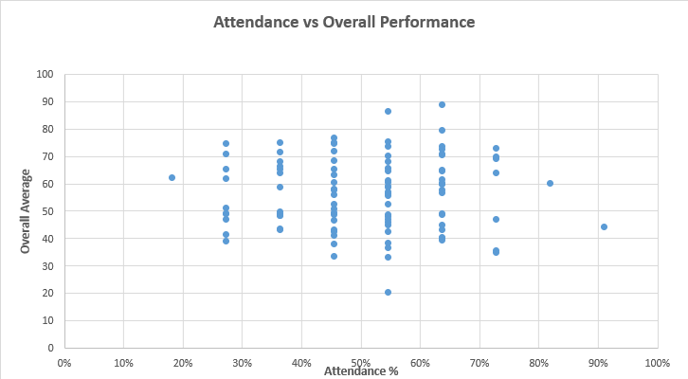

Part 2:
- Normalisation:
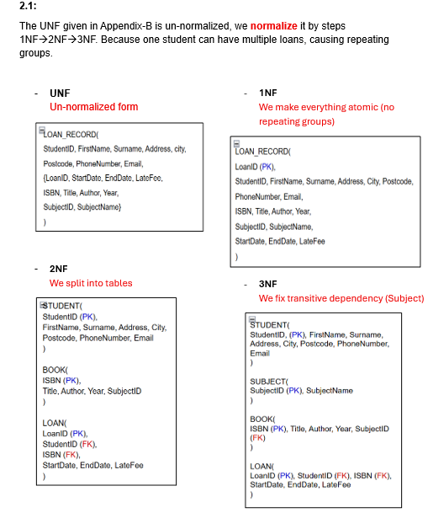

- Conceptual ERD: shows the main entities and their relationships.
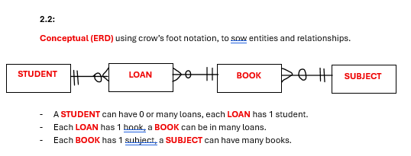

- Logical ERD: Includes attributes, primary keys, and foreign keys, defining the structure of the database.
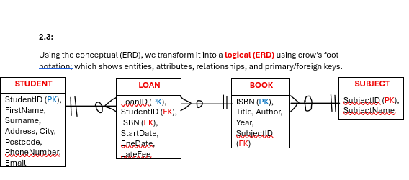
- Physical ERD: defines table structure, including data types, field sizes, and constraints.
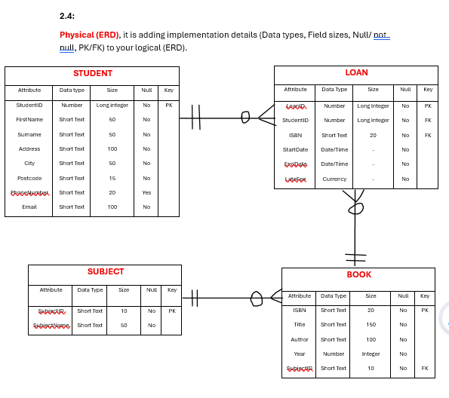

- Database Implementation in Access (Check the file too):
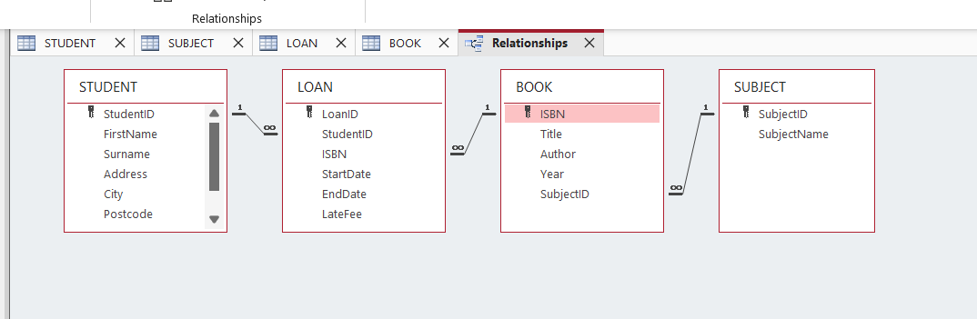
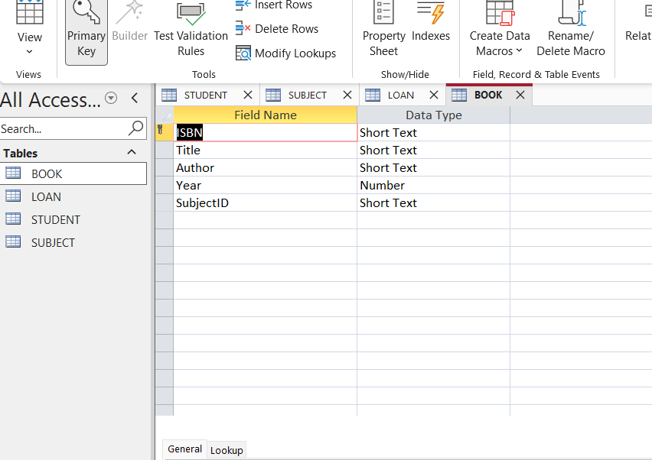
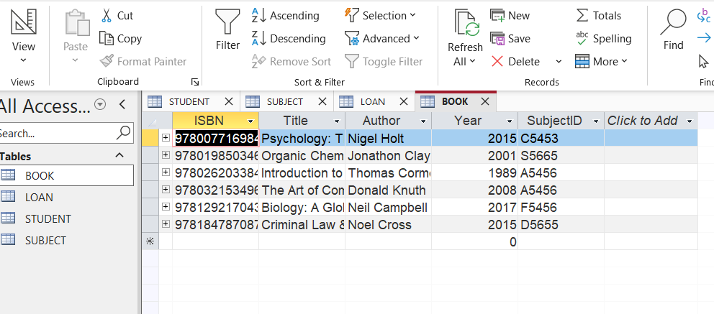
Conclusion:
This coursework demonstrated the use of spreadsheets and databases to manage and analyze data. The application of formulas, visualization tools, and database design ensured an efficient and structured system.

